Alternatieve intro writing

Geel papier

puntenslijper

**The monster story**

**We all judge…**

It is easy to judge, but hard not to. Who are we judging and upon what do we base our judgements? Do we really know that person? How often have you been proven wrong?

**I want you to draw a monster…**

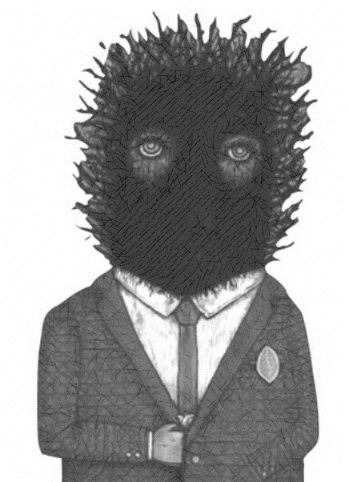You are going to draw a monster. Use your imagination, be creative and do the best you can and remember, he or she is going to be the main character in your story.

**Your assignment** is to write a plausible backstory for the monster that makes it a sympathetic character. Prove that we judge too easily, take me on a journey …

*-Write at least half a A4 sheet*

*-Choose your setting according to your study:*

*>Monster in the flowershop*

*>Monster veterinarian*

*>Monster from the sea*

*>Monsterchef*

*-Use the questions below as a starting point:*

1. What’s your monster’s name?
2. Where does the monster live?
3. Who does he live with?
4. What is his favourite food?
5. What does he love to do?
6. Does he have any friends?
7. What is his favourite song?
8. Why do people think he’s a bad monster?

Remember that this is a story, so don’t just make a summary, but try to make a actual story.

Start like this:

The monster thought about what happened last night.